CHAPTER 4

ANALYSIS AND DESIGN

Use Case Specification and UML Diagrams
Manage Evaluation

4.1 Introduction
This document presents the detailed design of the fourth use case of the PSM Assessment System, namely Manage Evaluation. The use case covers the assessor marking one evaluation form against its rubric, from opening the form to the moment the mark becomes visible to the student. It is specified in Table 4.4, then expressed as a sequence diagram in Figure 4.7 and an activity diagram in Figure 4.8.

4.2 Use Case Specification
Manage Evaluation is the only route by which a mark enters the system. It is deliberately small: a coordinator allocates forms, each assessor marks their own, and every assessor's contribution is aggregated into the project's final mark. Table 4.4 summarises the use case.
Table 4.4: Use Case Specification for Manage Evaluation
Use Case ID | UC-04
Use Case Name | Manage Evaluation
Actor | Assessor, being the supervisor, an examiner or a lecturer (primary); Coordinator (allocates forms). The student may read their own released mark.
Description | The assessor opens the evaluation form the coordinator allocated to them and marks each criterion on a 0 to 5 scale. The system converts each item score to the rubric's own weight, so Lampiran J still totals 40 while the marker answers on a 0 to 5 scale. When every criterion is marked the assessor submits the form, which locks it, recomputes the project's aggregate and makes the mark visible in the same step.
Pre-condition | The coordinator has allocated the form to the assessor and has opened the assessment window for that form. The milestones the form depends on are approved.
Trigger | The assessor opens a form from their dashboard.
Main Flow | 1. The assessor opens an allocated form.  2. The system confirms the assessor may read the form.  3. The system loads the rubric snapshot and the student's score rows.  4. The system renders one 0 to 5 select per criterion.  5. The assessor chooses a score for each criterion and may add a comment.  6. The system confirms the form is still editable.  7. The system confirms the form's own assessment window is open.  8. The system converts each item score to the criterion's weight.  9. The system stores the weighted mark and keeps the item score beside it.  10. The assessor submits the form.  11. The system confirms that every criterion has been marked.  12. The system recomputes the form's percentage.  13. The system marks the form submitted and records whether it was late.  14. The system recomputes the project's final mark.  15. The system reconciles the release flag so the student can see the mark.  16. The system notifies the coordinator and the student.
Alternative Flow | A1. The form's assessment window is not open: the system refuses the mark with 422. The window is per form, so opening Lampiran E does not open Lampiran I.  A2. The form is no longer editable, being already submitted: the system refuses the change. Only the assessor who holds the form may mark it, and a submitted form is locked.  A3. An item score is outside 0 to 5: the system refuses it and the assessor corrects the score.  A4. The assessor submits with a criterion unmarked: the system refuses and names each unmarked criterion. An unmarked form is not a zero.  A5. A milestone the form depends on is not approved: submission is refused, because the form would certify work that has not been accepted.  A6. The assessor declares a conflict of interest: the form is marked recused and the coordinators are notified so a replacement can be allocated. A recusal is final.
Post-condition | On success, the form is submitted and locked, the project's aggregate has been recomputed and the student can see their mark. The item scores, the converted marks, the submitter and the submission time are all retained. A student who did not attend is assessed as zero, which the assessor types; the system never assumes a zero.

Two rules in Table 4.4 replaced features that no longer exist and must not be reintroduced. First, there is no release step: submitting the form recomputes the aggregate and reconciles visibility in one call (step 15), because a separate Release button let the aggregate and the flag that exposes it be changed independently. Second, there is no moderation: a coordinator does not alter marks, so if a mark is genuinely wrong the assessor revises it rather than a second party editing the number.
The distinction in A4 matters for the same reason. A form with an unmarked criterion is incomplete, and an incomplete form is refused; a student who did not attend is complete and carries zeroes. Treating the two alike would either publish a mark that was never given or block a legitimate fail.

4.3 Sequence Diagram
The sequence diagram in Figure 4.7 shows the use case across six lifelines: the assessor, the evaluation interface, the evaluation controller, the evaluation service, the rubric and score data, and the services that publish and record the mark. It is divided into marking, saving and submitting.
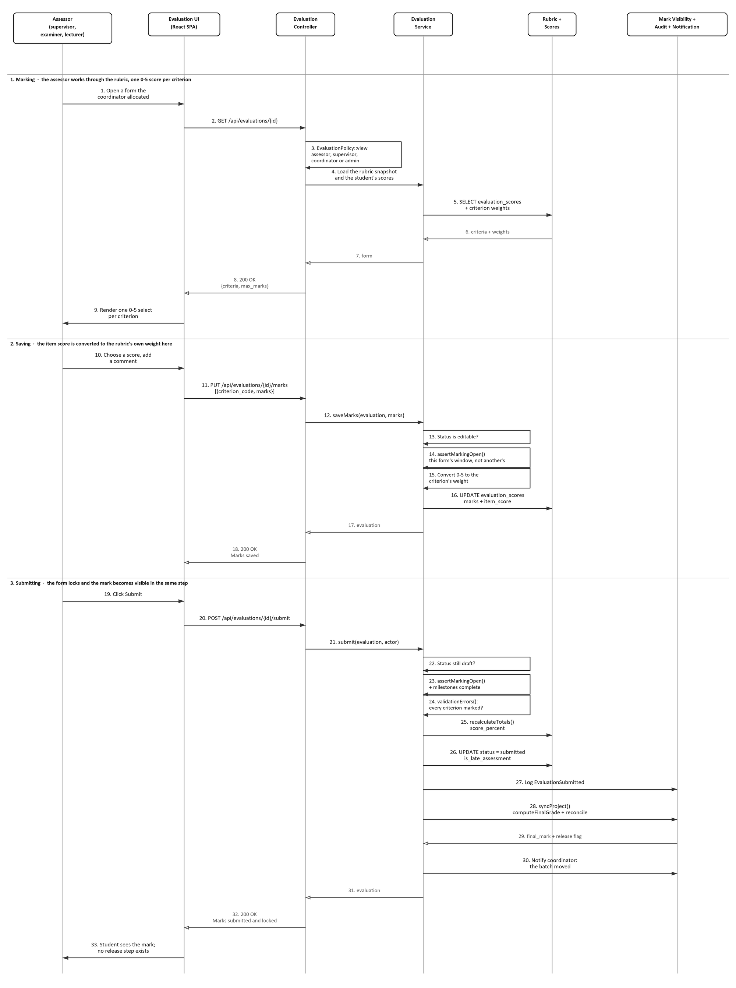
Figure 4.7: Sequence Diagram for Manage Evaluation
The marking section is a read: messages 4 to 7 load the rubric snapshot and the student's score rows, and message 9 renders one select per criterion. The saving section is where the arithmetic happens. Message 13 confirms the form is still editable and message 14 confirms its own window is open; message 15 then converts the 0 to 5 item score into the criterion's weight, and message 16 stores the weighted mark with the item score kept beside it. Both are stored because they answer different questions: the weight is what the mark is worth, the item score is what the assessor actually said.
The submitting section is the one that must not grow a second signature. Message 24 refuses an incomplete form, message 25 recomputes the percentage, and messages 27 and 28 record the submission and publish the mark. Message 29 is the aggregate coming back and message 30 tells the coordinator the batch moved. There is no message to a moderator and no message to a release step, because neither exists.

4.4 Activity Diagram
The activity diagram in Figure 4.8 shows the same use case as a workflow. The marking route runs down the centre through four decisions, each corresponding to an alternative flow, and each refusal leaves into a single column on the right. The assessor's own conflict-of-interest declaration is the one branch that leaves from the spine itself, and it joins the column at the end node rather than returning to the marking route.
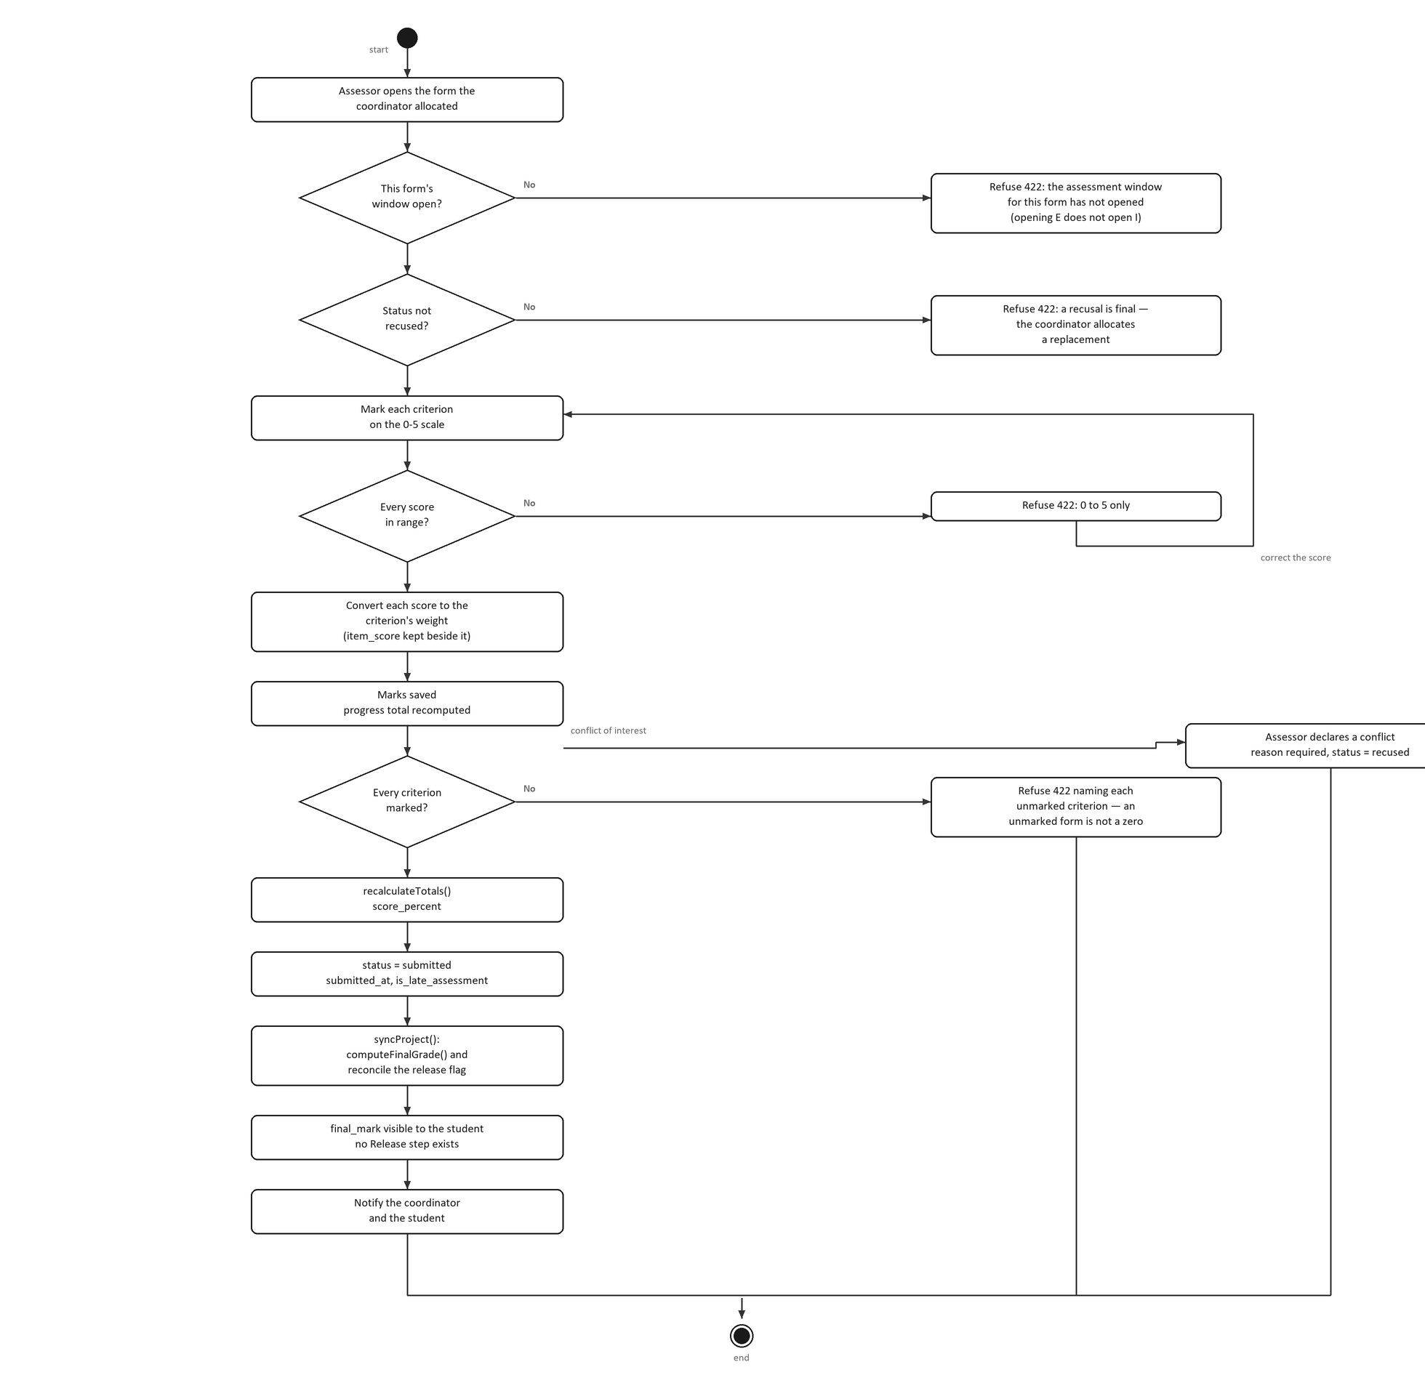
Figure 4.8: Activity Diagram for Manage Evaluation
The first two decisions are gates rather than validations: the form's own assessment window must be open (A1), and the form must not have been recused (A2). The third is a correction loop: a score outside 0 to 5 is refused and the assessor marks again. The fourth is the completeness check (A4), and it is the last thing between the assessor and a published mark.
After that decision the route is straight and short on purpose. The form's percentage is recomputed, the form is locked, the project's final mark is recalculated and the release flag is reconciled in the same pass, and only then is anybody notified. The step labelled "no Release step exists" is drawn deliberately: it is the point at which an earlier design expected a coordinator to press Release, and nothing there any more.

4.5 Chapter Summary
This document has specified the Manage Evaluation use case and presented its sequence diagram and activity diagram. The specification defines the assessor as the only actor who marks, a sixteen step main flow and six alternative flows. The sequence diagram shows marking, saving and submitting as message exchanges across six objects, and the activity diagram shows the workflow with its two gates, a correction loop and the completeness check that separates a mark from a guess.

